**Tableau Server Training**

### [Introduction to Tableau Server, Installation and Configuration](https://mindmajix.com/tableau-server-training#collapse-curriculum-501)

**Tableau Server Architecture**

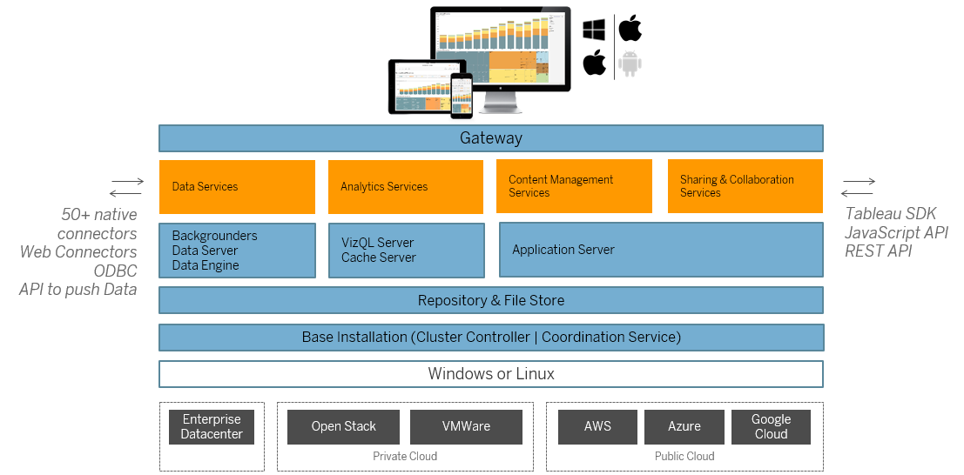

**Tableau Server Processes**

<https://help.tableau.com/current/server/en-us/processes.htm>

**Gateway/Load Balancer**: The Gateway is a web server that handles all requests to Tableau Server from browsers, Tableau Desktop, and other clients, and routes requests to other components. Requests that come in from the client first hit an external load balancer, if one is configured, or the gateway and are routed to the appropriate process. In the absence of an external load balancer, if multiple processes are configured for any component, the Gateway will act as a load balancer and distribute the requests to the processes. In a single-server configuration, all processes sit on the Gateway, or primary server. When running in a distributed environment, one physical machine is designated the primary server and the others are designated as worker servers which can run any number of other processes. Tableau Server always uses only one machine as the primary server.

**Application Server**: Application Server processes (wgserver.exe) handle **content browsing, server administration, REST API calls and permissions** for the Tableau Server web and mobile interfaces. When a user opens a view in a client device, that user starts a session (workgroup_session_id) on Tableau Server. The default timeout for this session is easily configuration by an administrator. You can run two or more application server processes to meet your scalability and availability needs.

**VizQL Server:** The VizQL Server loads and renders views, computes and executes queries. Once the user is authenticated via the application server, the user can open a view. The client sends a request to the VizQL process (vizqlserver.exe). The VizQL process then sends queries directly to the data source, returning a result set that is rendered as images and presented to the user. In many cases, Tableau Server leverages client-side rendering and caching to reduce the load on the server.

**Cache Server:** The Cache Server is a query cache distributed and shared across the server cluster. This in-memory cache speeds user experience across many scenarios. VizQL server, backgrounder, and data server (and application server to a lesser extent) make cache requests to the cache server on behalf of users or jobs. The cache is single-threaded, so if you need better performance you should run additional instances of cache server.

**Data Server:** The Data Server manages connections to Tableau Server data sources. It lets you centrally manage, and store Tableau data sources and provides end users with secure access to trusted data in a self-service analytics deployment. You can centrally manage metadata, such as connections, drivers, and data source filters for data access.

**Data Engine:** The Data Engine creates data extracts and processes queries.

**Backgrounder:** The Backgrounder runs server tasks, including extract refreshes, subscriptions, ‘Run Now’ tasks, and tasks initiated from tabcmd. The backgrounder is designed to consume as much CPU as is available so as to finish the background activity as quickly as possible.

**Installation process and configuration of Tableau Server**

**Infrastructure Planning**

Before you install Tableau Server, you should review the disk requirements, recommended configurations, user accounts, security, and networking requirements.

The following list describes the minimum hardware recommendations for a single- node installation of Tableau Server:

* 8 core, 2.0 GHz or higher processor
* 64-bit processor architecture
* 32 GB memory
* 50 GB disk space available

The following list describes the hardware recommendations for a single- node installation of Tableau Server:

* 8 physical cores, 2.0 GHz or higher processor
* 64-bit processor architecture
* 64 GB memory
* 500 GB disk space available

Planning Phase - <https://help.tableau.com/current/server/en-us/requ.htm>

**Install and Configure Tableau Server**

Open the below link and follow the steps to install Tableau Server.

<https://help.tableau.com/current/server/en-us/install_config_top.htm>

**Upgrade Tableau Server**

Open the below link and follow the steps to Upgrade Tableau Server.

<https://help.tableau.com/current/server/en-us/upgrade.htm>

### [Server Web Interface, Sites, Projects, Users](https://mindmajix.com/tableau-server-training#collapse-curriculum-502)

* 1. Familiarizes users to the Server web interface,
  2. Creation of Sites, Projects and Users.

### [Projects, Sites, Site Users, Publishing Workbook](https://mindmajix.com/tableau-server-training#collapse-curriculum-503)

* 1. Creation of Projects, Sites, Users
  2. Site Users and publishing workbook under projects and the maintenance activities around these.

### [Reconfiguring the Server, Server Processes](https://mindmajix.com/tableau-server-training#collapse-curriculum-504)

* 1. Reconfigure the Tableau server and introduction to the various Tableau Server Processes.

### [Interactive Dashboard on Tableau Server](https://mindmajix.com/tableau-server-training#collapse-curriculum-506)

* 1. Creating an interactive dashboard  
     Publishing it on to the server and interacting with the dashboard on the server.

### [Navigating between dashboards in Server, Features of the Server Web Interface](https://mindmajix.com/tableau-server-training#collapse-curriculum-507)

* 1. Navigating between dashboards on the servers and the features of the Server Web Interface

### [Permission to user groups, permissions on workbook and projects](https://mindmajix.com/tableau-server-training#collapse-curriculum-508)

* 1. Creation of user groups and permissions.  
     Shows how the permissions are applied on workbooks and projects.

### [Customized Views](https://mindmajix.com/tableau-server-training#collapse-curriculum-509)

* 1. Explains about the ‘Remember my changes’ options on Tableau Server that helps in creating customized views.

### [Data Sources, Publishing Data Sources, Permission on Data Sources, Data Server](https://mindmajix.com/tableau-server-training#collapse-curriculum-510)

* 1. Introduction to Data Sources  
     Data Server and Explanation of how to publish data sources,  
     Apply permissions on Data Sources

### [Admin Views, Creating custom Admin Views](https://mindmajix.com/tableau-server-training#collapse-curriculum-511)

* 1. Analysing Standard Admin views provided by Tableau server and how to create custom admin Views

### [Schedules & Extracts, Refresh Extracts from](https://mindmajix.com/tableau-server-training#collapse-curriculum-512) Tableau Server

* 1. Explain about creation of schedules  
     Attaching extracts to the schedules  
     Refreshing extracts from Tableau Server

### [Schedule Alerts, Server Maintenance & Data Connections](https://mindmajix.com/tableau-server-training#collapse-curriculum-514)

* 1. Handling the alerts generated by Schedule due to any issue.  
     Explains about Server maintenance and Data Connections

### Backup and Restore

Perform a Full Backup and Restore of Tableau Server

<https://help.tableau.com/current/server/en-us/backup_restore.htm>

### [Customizing the Server](https://mindmajix.com/tableau-server-training#collapse-curriculum-515)

* 1. Changing the Name and Logo on the server to include the company name and logo.

### [Tableau TCP-IP](https://mindmajix.com/tableau-server-training#collapse-curriculum-516)

* 1. This explains the different ports used by Tableau Server and ways to change the default ports

### [Tableau Security](https://mindmajix.com/tableau-server-training#collapse-curriculum-517)

* 1. Explains about the Network Security and Data Security components  
     How to create user filters as a part of Data Security  
     Familiarizes users with setting up proxy server  
     Run as User and SQL Server Impersonate concepts

### [Embed Views, List of Parameters, JavaScript API](https://mindmajix.com/tableau-server-training#collapse-curriculum-518)

* 1. This Module explains about embedding Tableau views into a website, using embed parameter and introduction to JavaScript APIs

### [Server Performance](https://mindmajix.com/tableau-server-training#collapse-curriculum-519)

* 1. This explains about Tableau Server Performance Management  
     Performance recorder and analysing the performance.

### [Server Scalability](https://mindmajix.com/tableau-server-training#collapse-curriculum-520)

* 1. Illustrates how to Scale up/ Scale out Tableau Server to meet the requirements of the company.

### [Configure for Failover, High Availability](https://mindmajix.com/tableau-server-training#collapse-curriculum-521)

* 1. Explains how to configure Tableau Server for Failover and high availability

### [Tabcmd & Tabadmin Utility](https://mindmajix.com/tableau-server-training#collapse-curriculum-522)

* 1. Introduction to the tabcmd command line utility and explains it’s usage.
  2. Introduction to the tabadmin command line utility and explains it’s usage.

### [Troubleshooting – License, VizQL, Data Source](https://mindmajix.com/tableau-server-training#collapse-curriculum-524)

Troubleshooting various issues with License, VizQL and Data Sources

Troubleshooting various issues using Logs. Carrying out the Database maintenance.